10. A child is brought into ED 30 minutes after being bitten on the ankle by a Snake
a. List 5 questions you would ask the parents in your History.
b. What are 3 steps in the management of this child?
c. What are 3 exam findings you would expect for a child bitten by a snake?

11. A patient with a diagnosis of Bipolar is brought to the ED by the police.
a. List 2 physical signs of mania in a patient with bipolar disorder
b. List 3 collateral questions to ask their family members

12. Woman with PID
a. List 4 examination/investigation findings you would expect in a person with PID
13. Patient presented to her GP a few weeks ago with fatigue, she thinks she is iron deficient, but blood tests return normal. She returns today distressed and can’t sleep. She becomes teary during the consultation.

a. List 4 Differential Diagnoses for this presentation

14. A patient is having withdrawal symptoms from heroin and wants your help.
a. What are two questions you would ask the patient when taking the history?
b. What is the MOA buprenorphine and how can it help this patient?
c. What are 2 considerations you must make before starting this patient on Buprenorphine.
15. Healthy 22 years female patient comes into GP post-surgery, otherwise well.

a. What 2x preventative things could you offer and how would you explain the benefit of each one to the patient?
16. Mother who is 34 weeks pregnant presents to hospital with HTN, proteinuria and epigastric pain.
a. List 4 clinical examination findings.

b. What is the most likely diagnosis in this patient?
c. What are 2 fetal complications of this diagnosis?
d. What are 2 maternal complications of this diagnosis?

17. Refugee presents to a GP seeking help for depression and low mood.
a. What are 4 history Questions to assess high risk for suicide in the same day
18. Rhesus negative mother G1P0
a. List some situations when she would need Anti-D?
b. When during pregnancy is anti-D prophylaxis Given?

19. Pregnant woman 8 weeks of gestation, positive home pregnancy test, with bleeding and lower abdo pain.
a. List 4 Differential Diagnoses

20. Patients present for their first antenatal check-up at 8 weeks gestation, confirmed intrauterine pregnancy on ultrasound. All initial antenatal screening was negative.

a. What are 6 screening things done routinely throughout pregnancy for preventative healthcare (not including initial blood test at the first visit like Hep B, C etc)
21. Man comes in with a palpable groin mass. On examination, there is a 2cm palpable lymph node in the right groin.
a. List 4 DDx for Lymphadenopathy Specifically
b. What is the gold standard Investigation for lymphadenopathy?
c. List 3 other sites that would need to be examined.

22. 39F comes in for a repeat COCP. She has been on it for years and happy to continue
a. What are 4 contraindications to the COCP?
b. What are 4 lower-risk alternatives to the COCP?

23. Patient is being administered zoledronic acid by a nurse, who steps out into another room, you are the medical student, and you notice they are suddenly pale and coughing.
a. What is your Diagnosis?
24. Liver CT
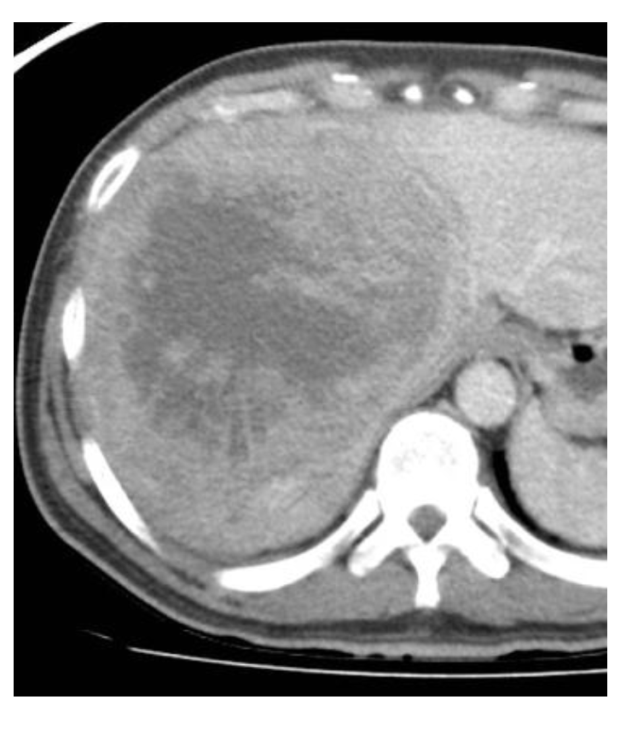
a. List 2 features on this CT
b. What is your leading Differential Diagnosis?

25. Patient presents with haematemesis and dark tarry stools, hepatosplenomegaly. Blood tests results given:
Low Hb
MCV high
Thrombocytopenia
Low albumin

AST = 86 (5-35)
ALT = 122 (5-35)
a. Why is the patient tired & why do they have oedema?
b. What 3 aspects of social history would you inquire about in order to determine the diagnosis?
c. What is the significance of their raised AST/ALT?
26. Patient case painting a picture of nephrotic syndrome, which includes examination findings and some blood tests (24hr urine = 4g protein, hypertensive, 4 RBCs in urine, fatty casts in urine, total cholesterol = 8, oedema to shin and periorbital).
a. 4 DDx
b. 3 Ix
c. 3 Mx
d. 2 complications untreated

27. A 3 year old Child UTI
a. 4 risks for UTI in Children
b. 3 Common organisms that cause UTI in children
c. What Ix would you order in a child with recurrent UTIs – Justify each Ix.

28. Patient is 3 days post hemi-colectomy and has started on PO fluids. Has developed abdominal pain, guarding, afebrile, and constipation, and urine output is XXX ml/hr (was it 10ml?) in the last 2 hours.
a. 4 DDx

b. 6 immediate Mx

29. Nurse calls you to review a patient in a nursing home who has started acting confused 24-48h of Symptoms. Nurse thinks the patient has delirium.
a. List 4 DDx
30. 42 yo male with painless non-febrile haematuria, on aspirin, beta-blocker, ACE-I. Nonsmoker, does not drink.
a. List 5 DDx
b. List 5 Ix

31. Mother brings her child in who she felt was hot, then developed a seizure.
a. List 4 aspects of the history that indicate it was a simple febrile seizure
b. List 3–5 Mx steps

32. Patient is a few days post radical prostatectomy, and develops SOB and distress a few hours ago.

a. List 4 causes
b. Give 6 questions on history that would differentiate the cause.

33. Case with a 2-year-old child who is dehydrated - slightly sunken eyes, decreased alertness but easily arousable, cap refill 2sec, dry mucous membranes, normal BP, HR and RR.
a. List 4 assessment categories that determine their hydration status.
b. Does the child have Mild, Moderate or Severe Hydration & Why?
34. 45-year-old presents multiple swollen joints in hands, MCP, PIP, symmetrical, worse in the morning.

a. What are the 4 most likely diagnoses?

b. What are 6 investigations you would order?
35. Mental Health

a. List 5 features of PTSD

